

Open-Ended Lab Report Terraform & Ansible – Frontend Backend

High Availability Architecture

Student Name: Nayab Khazin Registration No: 2023-BSE-046 Course: Cloud Computing
Lab Type: Open Ended Lab

Contents
Open-Ended Lab Report Terraform & Ansible – Frontend Backend High Availability Architecture
. 1
- Introduction 3
- GitHub Repository Initialization 3
- GitHub Codespaces Environment Setup 3
- Tool Installation & Verification 3
- Final Project Directory Structure 4
- Terraform Configuration 5
  - Provider & Variables Definition 5
  - Local Values & IP Restriction 6
  - Networking (VPC, Subnet, Routing) 6
  - EC2 Frontend & Backend Provisioning 7
  - Terraform Outputs 8
  - Terraform Modules Implementation 9
- Ansible Configuration 12
  - Ansible Configuration File 12
  - Inventory File 13
  - Backend Role (Apache HTTPD) 13
  - Frontend Role (Nginx Load Balancer) 14
  - Main Playbook (site.yaml) 15
- Terraform Apply & Automation Execution 15
- Backend Server Verification 15
- Frontend Load Balancer Verification 16
- Load Balancing Behaviour Validation 17
- Failover Testing (Backup Backend) 18
- Conclusion 18

Introduction

This report presents the complete implementation of an open-ended cloud computing lab using Terraform and Ansible.
The goal of this lab is to provision infrastructure automatically and configure a highly available frontend-backend web architecture.

GitHub Repository Initialization

A dedicated GitHub repository was created to maintain version control and ensure clean separation of this lab from previous assignments.
(Figure 1: GitHub Repository Creation)

GitHub Codespaces Environment Setup

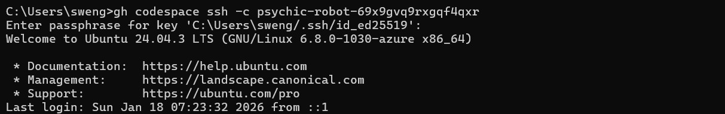
GitHub Codespaces was used as the development environment to provide a consistent Linux- based setup.
(Figure 2: Codespaces Environment)

Tool Installation & Verification

Required tools including Terraform, AWS CLI, Python, and Ansible were installed and verified before implementation.

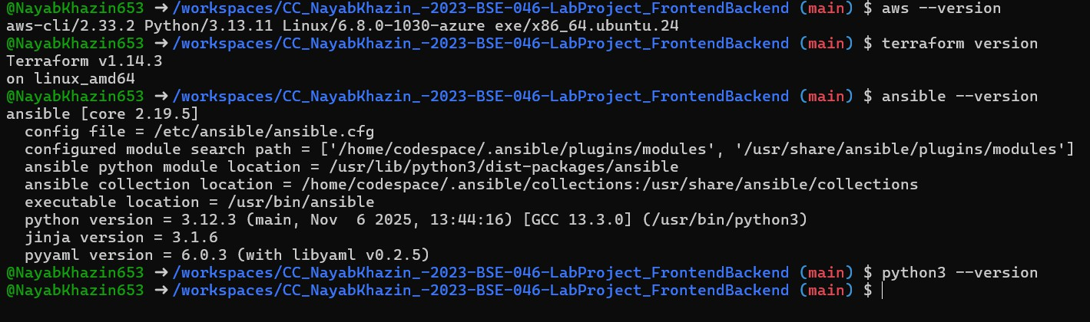
(Figure 3: Terraform Version, Ansible Version)

Final Project Directory Structure

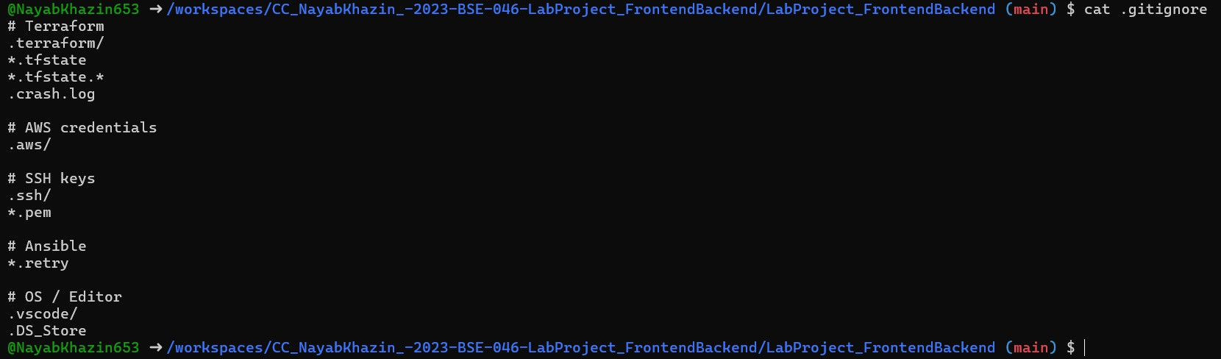
The final directory structure follows Terraform module-based design and Ansible role-based configuration.
(Figure 4: .gitignore file)

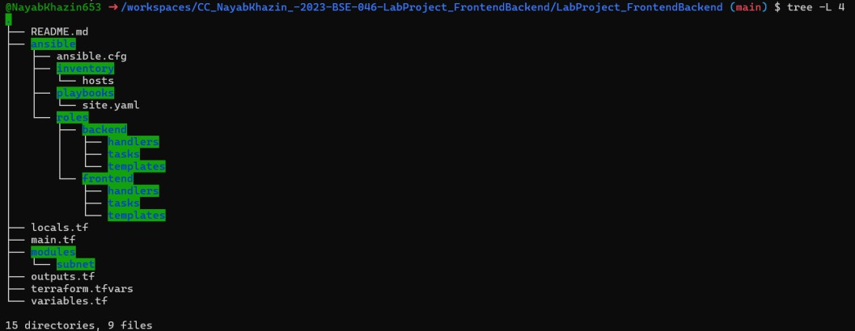
(Figure 5: Project Directory Tree)

Terraform Configuration

Provider & Variables Definition

Terraform provider configuration specifies the AWS region and credentials. Variables are used for reusability and flexibility.

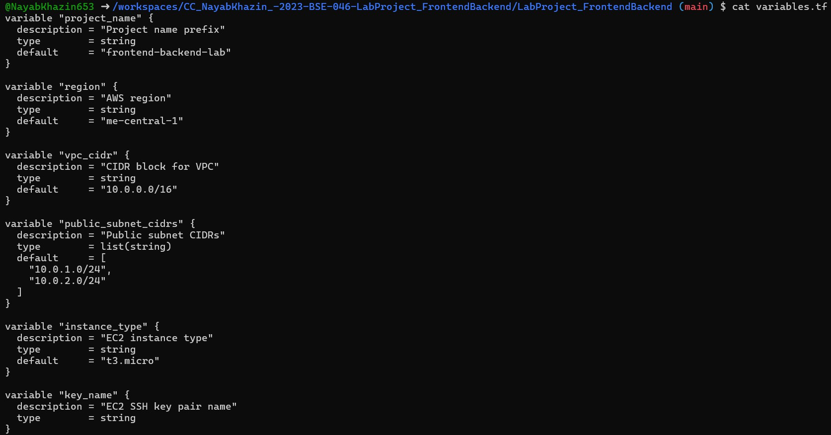
(Figure 6: variables.tf)

Local Values & IP Restriction

Local values dynamically retrieve the user's public IP to restrict SSH access securely.
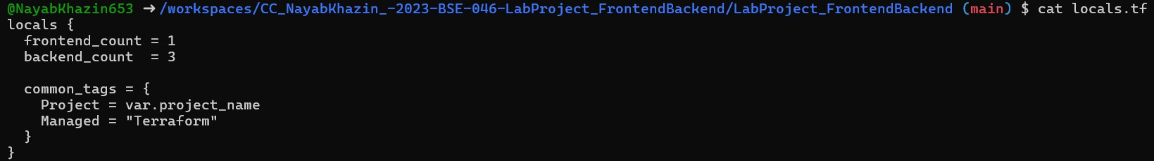
(Figure 7: locals.tf)

Networking (VPC, Subnet, Routing)

A VPC, public subnet, internet gateway, and route table are provisioned to allow internet access.

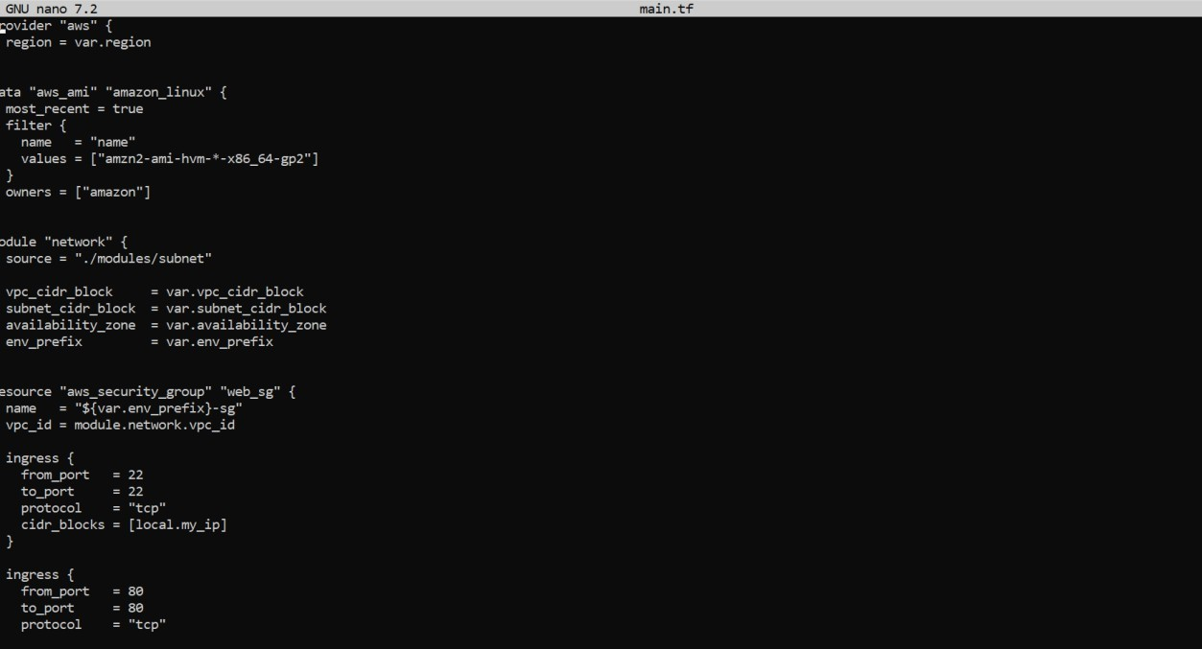
(Figure 8: VPC & Subnet Configuration)

EC2 Frontend & Backend Provisioning

One frontend EC2 instance and three backend EC2 instances are created using reusable Terraform modules.

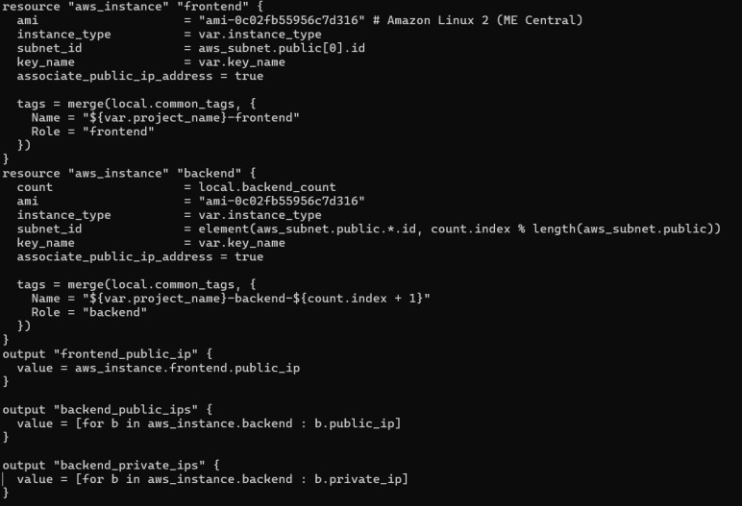
(Figure 9: EC2 Instance Creation)

Terraform Outputs

Terraform outputs expose public and private IP addresses required for Ansible inventory and verification.

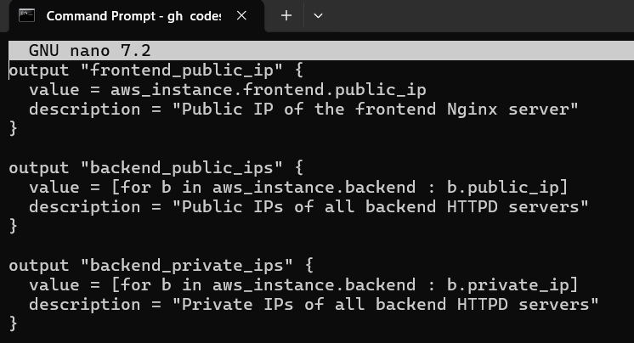
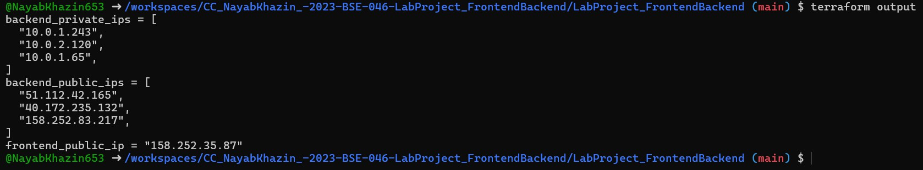
(Figure 10-A: outputs.tf)

(Figure 10-B: outputs.tf)

Terraform Modules Implementation

Terraform modules were used to improve code reusability, readability, and separation of concerns.
Instead of defining all resources in a single file, networking and compute logic were encapsulated into independent modules.

This approach aligns with infrastructure-as-code best practices and simplifies future scaling.

Subnet Module (Networking Layer)

The subnet module is responsible for provisioning the core networking components required for the project.
It creates the Virtual Private Cloud (VPC), public subnet, internet gateway, route table, and route table association.

This ensures that all EC2 instances are deployed in a properly configured public network with internet access.

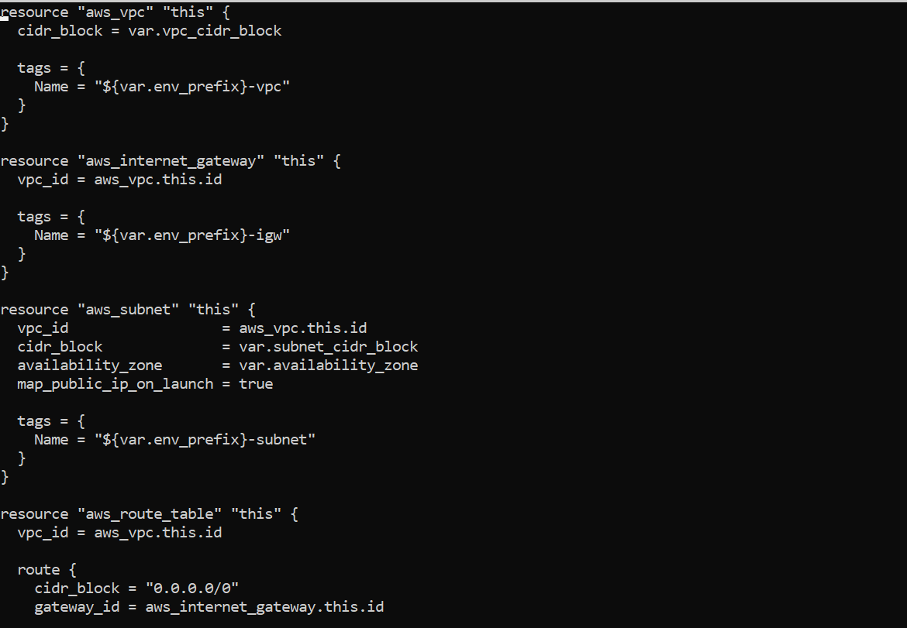
(Figure 12: Subnet module main.tf – VPC, subnet, and routing configuration)

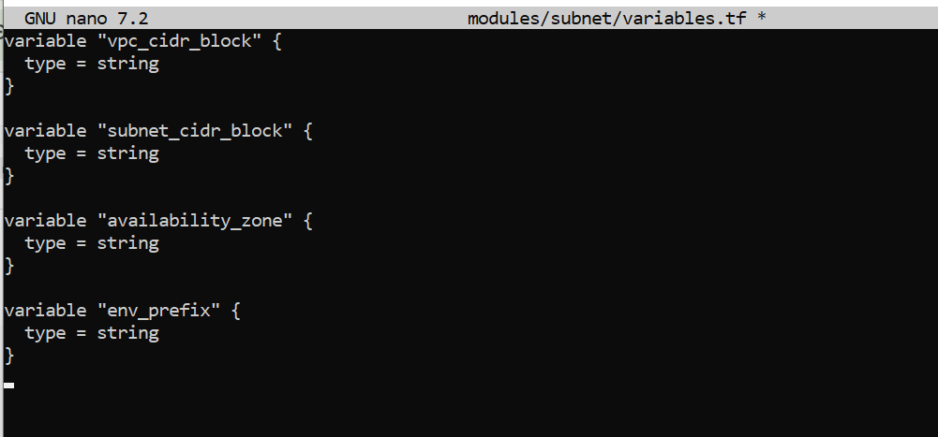
(Figure 13: Subnet module variables.tf)

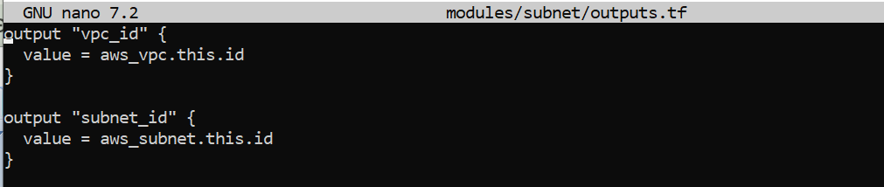

(Figure 14: Subnet module outputs.tf)

Webserver Module (EC2 Abstraction Layer)

The webserver module abstracts EC2 instance creation into a reusable component.
It is used to provision both frontend and backend instances by passing different parameters such as instance count and naming prefix.

This modular design avoids duplication and ensures consistent EC2 configuration.
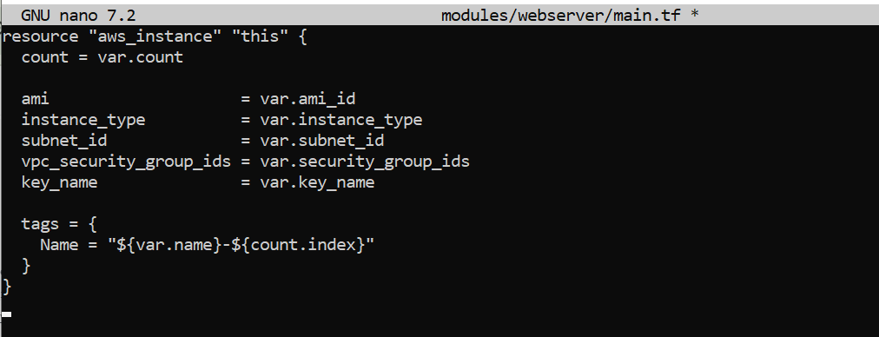

(Figure 15: Webserver module main.tf – EC2 instance resource definition)

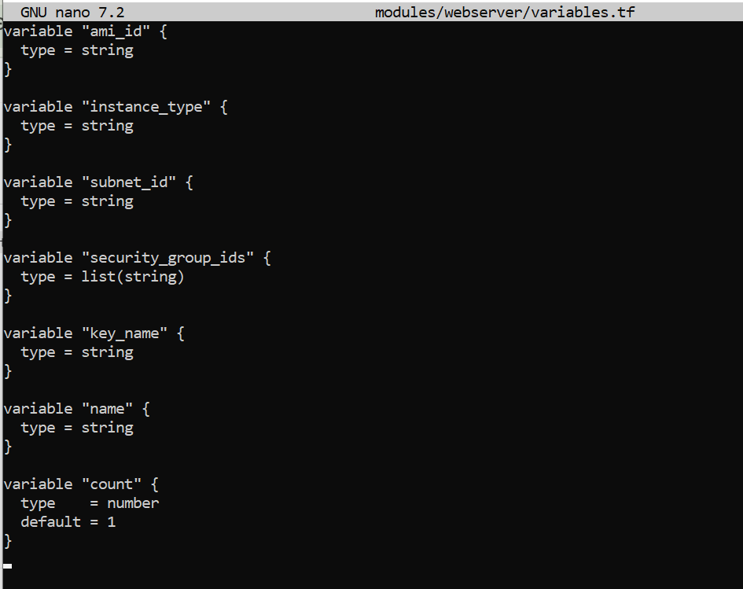
(Figure 16: Webserver module variables.tf)

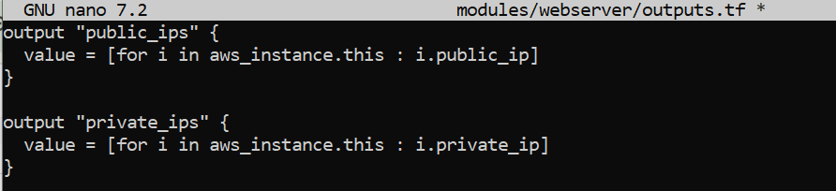
(Figure 17: Webserver module outputs.tf)

Ansible Configuration

Ansible Configuration File

The ansible.cfg file disables host key checking and specifies Python interpreter settings.

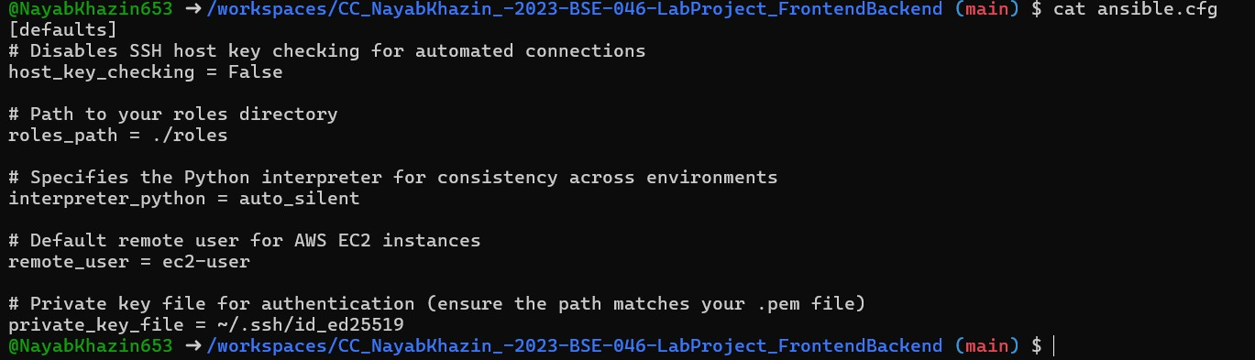

(Figure 18: ansible.cfg)

Inventory File

The inventory file groups frontend and backend servers to enable role-based execution.
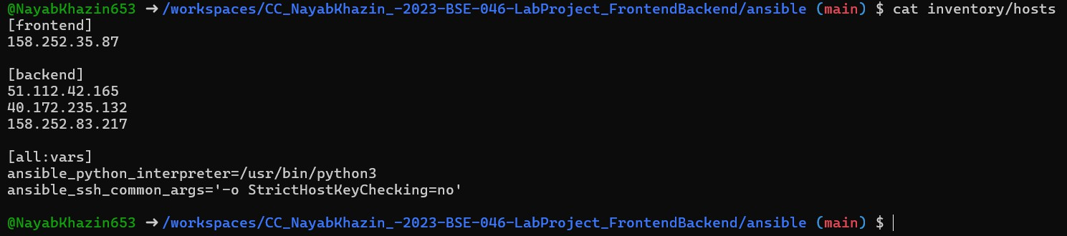
(Figure 19: Inventory hosts file)

Backend Role (Apache HTTPD)

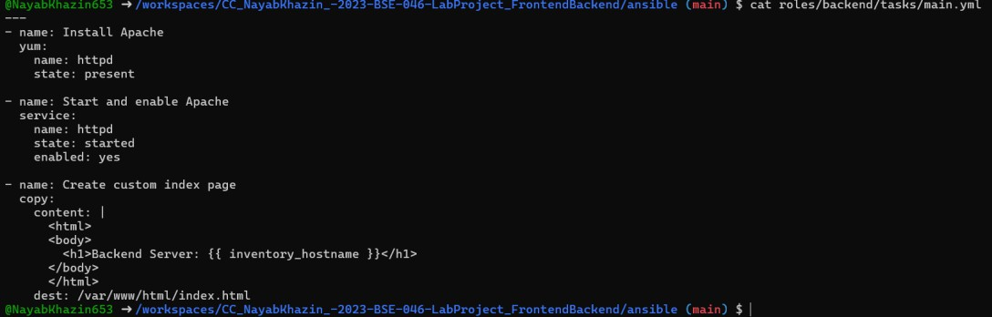
The backend role installs Apache HTTPD and deploys unique index pages on each backend server.
(Figure 20-A: Backend Role Tasks)

(Figure 20-B: Backend Role Templates)

(Figure 20-C: Backend Role Handler)

Frontend Role (Nginx Load Balancer)

The frontend role installs Nginx and configures it as a reverse proxy with two primary and one backup backend.
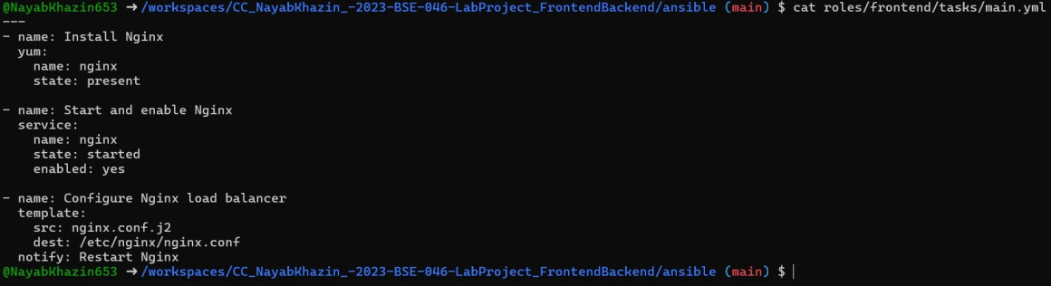
(Figure 21-A: Nginx Configuration Tasks)
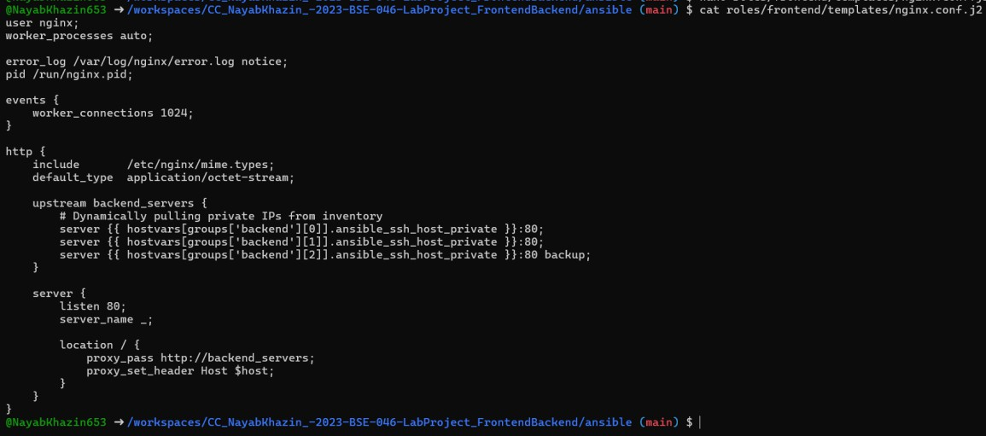

(Figure 21-B: Nginx Configuration Template)

(Figure 21-C: Nginx Configuration Handlers)

Main Playbook (site.yaml)

The main playbook applies backend configuration first, followed by frontend setup.
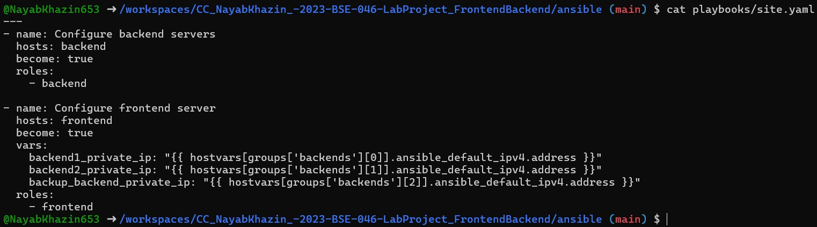
(Figure 22: site.yaml)

Terraform Apply & Automation Execution

Terraform apply provisions all resources and automatically triggers Ansible using a null_resource.
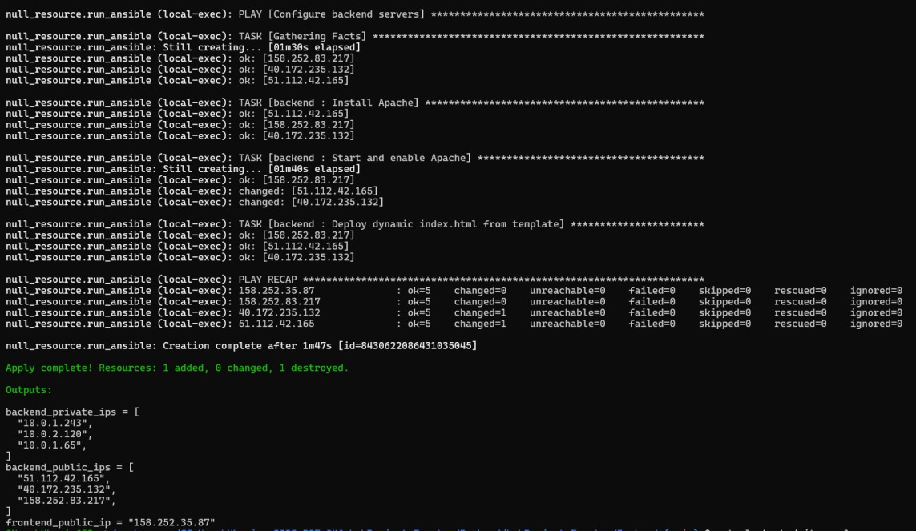
(Figure 23: Terraform Apply Output)

Backend Server Verification

The following unlabeled screenshots show direct access to backend servers using their public IPs.
Each backend displays a unique response, confirming correct Apache deployment.


(Figure 24: Backend Server 1 Output)



(Figure 25: Backend Server 2 Output)



(Figure 26: Backend Server 3 Output)

Frontend Load Balancer Verification

These unlabeled screenshots show frontend access via the Nginx load balancer public IP. Responses alternate between primary backend servers.

(Figure 27: Frontend Response – Backend A)

(Figure 28: Frontend Response – Backend B)

Load Balancing Behaviour Validation

Repeated refreshes confirm round-robin behavior between the two primary backend servers.

(Figure 29-A: Refresh-1)

(Figure 29-B: Refresh-2)

(Figure 29-C: Refresh-3)

(Figure 29-D: Refresh-4)

Failover Testing (Backup Backend)

Primary backend services were stopped to validate failover. Traffic was successfully routed to the backup backend.

(Figure 30: Backup Backend Response)

Conclusion

This lab successfully demonstrates automated infrastructure provisioning and configuration management.
The architecture meets all requirements of high availability, modularity, and automation.

